Q. Demonstrate HTTP server in Packet tracer.
Aim:- To demonstrate HTTP server in packet Tracer. Setup:
- 1 Pc ,1 switch ,2 Server.
- Connect Pc with switch and switch with the servers.
(3).Connect Router0 with PC0 via fastethernet0/0 using copper stright wire and Router1 with PC1 via fasethernet0/0 using cross-copper cord.
(4).Connect both router via fastethernet0/1 using cross-copper cord.
(5).Set the IP address and default gateway of both the PCs in ip configuration of both the PCs respectively.

Topology:
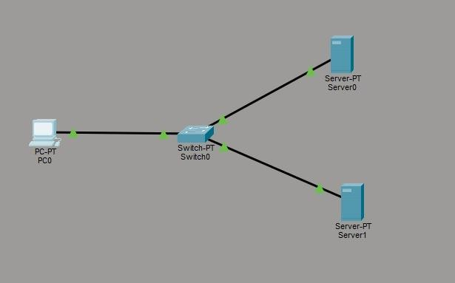
Config:
Server 0 (DNS Server)

Assign ip address 192.168.1.1
DNS Server 192.168.1.1
Server 1 (web server)
Assign ip address 192.168.1.2
DNS Server 192.168.1.1
DNS Server will be the same PC0
Assign ip address 192.168.1.3 DNS Server 192.168.1.1
- In DNS server 0 select and on DNS .
- Then go to web server http and edit the index.
- Name the website in DNS column and add the web server address and make on entity i the below list by clicking add.
- In PC0 open the desktop and then web browser write the name of the website if the edited html files contet displays ,then the topology has been succcessfully established.

PC0:

C:\ipconfig
C:\>ping 192.168.1.3

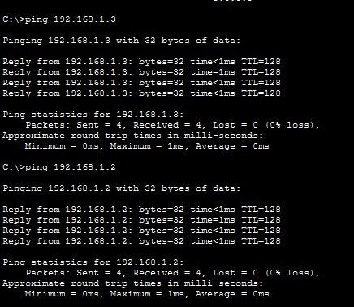

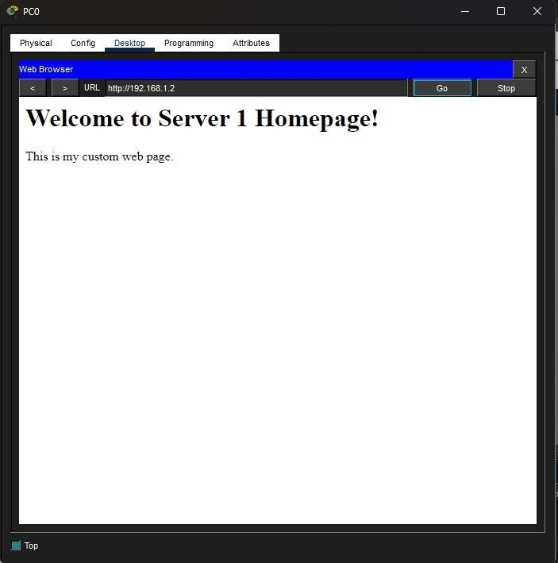
Conclusion:The above Topology has been executed successfully.

